AIM:

The aim is to slove the tic tac toe game using python program

PROGRAM:

def print_board(board):

for row in board:

print(" | ".join(row))

print("-" * 5)

def check_winner(board, player):

# Check rows

for row in board:

if all(cell == player for cell in row):

return True

# Check columns

for col in range(3):

if all(board[row][col] == player for row in range(3)):

return True

# Check diagonals

if all(board[i][i] == player for i in range(3)) or all(board[i][2 - i] == player for i in range(3)):

return True

return False

def is_board_full(board):

return all(cell != ' ' for row in board for cell in row)

def tic_tac_toe():

board = [[' ' for _ in range(3)] for _ in range(3)]

current_player = 'X'

while True:

print_board(board)

row = int(input(f"Player {current_player}, enter row (0, 1, or 2): "))

col = int(input(f"Player {current_player}, enter column (0, 1, or 2): "))

if board[row][col] == ' ':

board[row][col] = current_player

else:

print("Cell already occupied. Try again.")

continue

if check_winner(board, current_player):

print_board(board)

print(f"Player {current_player} wins!")

break

if is_board_full(board):

print_board(board)

print("It's a draw!")

break

current_player = 'O' if current_player == 'X' else 'X'

if __name__ == "__main__":

tic_tac_toe()

INPUT:

Player x enter ur move: 0

OUTPUT:

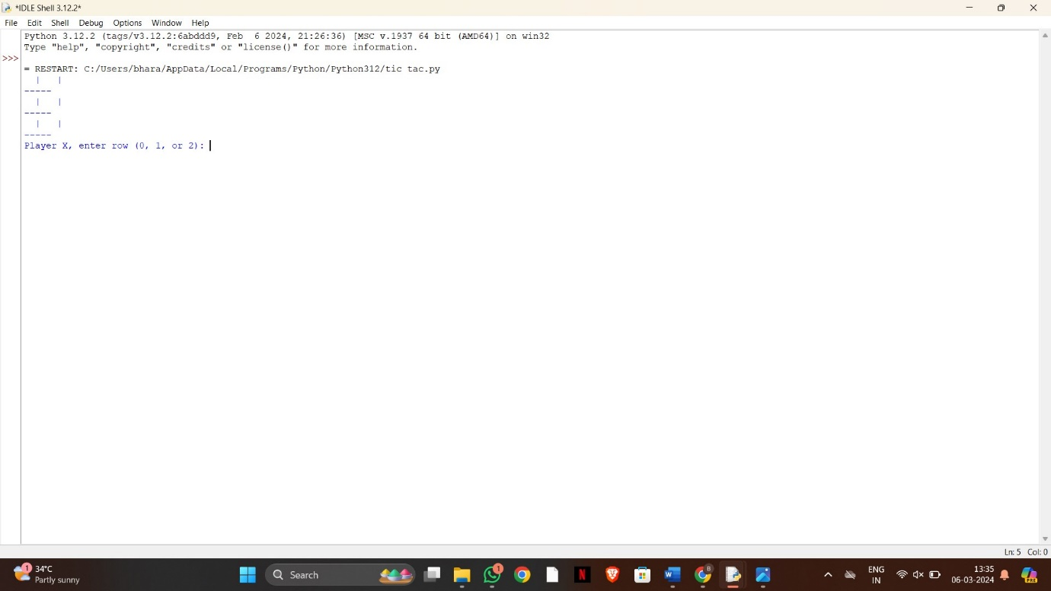

RESULT:

The tic tac toe game solving using python program is successfully completed